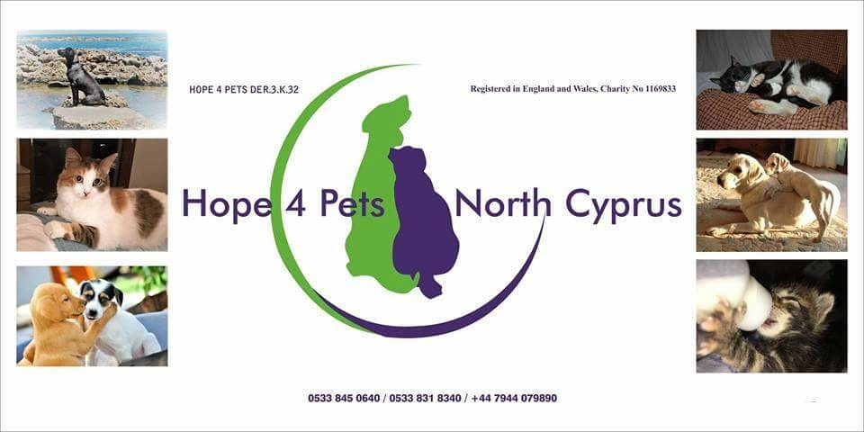
Red Ribbon (formerly Stroll Inn), Karakum
will present


A music and entertainment quiz
In aid of Hope 4 Pets
On Thursday 5th July 2018 at 7 p.m.
Tickets 50TL includes a buffet supper.
Come and join us to test your knowledge of music and films.
For reservation please phone Mick on
0533 877 4537

