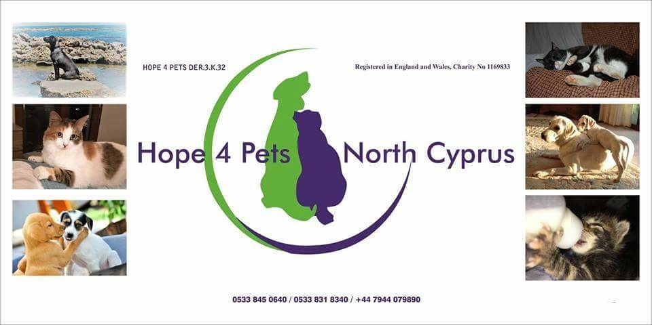
Red Ribbon, Karakum
will present

A music and entertainment quiz
In aid of Hope 4 Pets
On Thursday 8th November 2018 at 7 p.m.
Tickets 60TL includes a buffet supper.
Come and join us to test your knowledge of music and films.
For reservation please phone Mick on
0533 877 4537

