The Red Ribbon,
Karakum
Discounted drink prices on the night!
Discounted drink prices on the night!

is presenting

a music and entertainment quiz

with DJ Ozzie.

On Thursday 10th September 2020 at 7 p.m
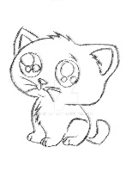
In aid of
Furry Friends,
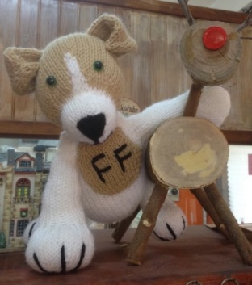
Kyrenia
“Helping people to help 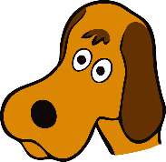
the street animals”

Tickets 70 T.L. each (including supper).
Come and join us to test your knowledge of music and films.
For reservations contact Barbara on
0542 865 7916 or via Furry Friends, Kyrenia FB page or email furryfriendskyrenia@gmail.com

