 |  | Fish eating season in Turkish name order
Fish |  | Turkish |  | Jan |  |  | Feb |  | Mar |  | Apr |  | May |  | Jun |  | Jul | Aug |  |  | Sep |  | Oct |  | Nov |  | Dec
Octopus |  | Ahtapot |  | AA |  |  | AA |  | AA |  | AA |  | AA |  | AA |  | AA | AA |  |  | AA |  | AA |  | AA |  | AA
Leerfish |  | Akya |  | B |  |  | B |  | B |  | B |  | B |  | AA |  | AA | AA |  |  | AA |  | AA |  | B |  | B
Sea Trout |  | Alabalık |  | AA |  |  | AA |  | AA |  | AA |  | AA |  | AA |  | AA | AA |  |  | AA |  | AA |  | AA |  | AA
Red Mullet |  | Barbunya |  | B |  |  | B |  | B |  | B |  | B |  | B |  | B | AA |  |  | AA |  | AA |  | AA |  | B
Small Bluefish |  | Çinekop |  | B |  |  | B |  | B |  | B |  | B |  | B |  | AA | AA |  |  | B |  | B |  | B |  | B
Gilt-head Bream |  | Çipura or çupra |  | B |  |  | B |  | B |  | B |  | B |  | B |  | B | B |  |  | AA |  | AA |  | B |  | B
Sole |  | Dil Balığı |  | B |  |  | B |  | B |  | B |  | B |  | B |  | B | B |  |  | B |  | AA |  | AA |  | AA
Anchovy |  | Hamsi |  | AA |  |  | AA |  | X |  | X |  | X |  | X |  | X | X |  |  | X |  | X |  | AA |  | B
Scorpion Fish |  | İskorpit |  | X |  |  | X |  | X |  | X |  | B |  | B |  | B | X |  |  | X |  | X |  | X |  | X
Horse Mackerel |  | İstavrit |  | AA |  |  | AA |  | AA |  | AA |  | B |  | B |  | B | B |  |  | B |  | B |  | B |  | B
Blotched Picarel |  | İzmarit |  | X |  |  | AA |  | AA |  | AA |  | B |  | X |  | X | X |  |  | X |  | X |  | X |  | X
Turbot |  | Kalkan |  | A |  |  | AA |  | AA |  | AA |  | B |  | X |  | X | X |  |  | X |  | X |  | B |  | B
Sea Bream |  | Karagöz |  | B |  |  | B |  | B |  | B |  | B |  | B |  | B | B |  |  | B |  | AA |  | AA |  | B
Goby |  | Kaya balığı |  | B |  |  | B |  | B |  | B |  | B |  | B |  | B | B |  |  | B |  | B |  | B |  | B
Grey Mullet |  | Kefal or Kafal |  | AA |  |  | AA |  | AA |  | AA |  | AA |  | X |  | X | X |  |  | X |  | AA |  | AA |  | B
Swordfish |  | Kılıç balığı |  | B |  |  | B |  | B |  | B |  | B |  | B |  | B | AA |  |  | AA |  | B |  | B |  | AA
Red Gurnard |  | Kırlangıç |  | A |  |  | A |  | A |  | AA |  | AA |  | AA |  | AA | AA |  |  | AA |  | A |  | A |  | A
Chub Mackerel |  | Kolyoz |  | A |  |  | A |  | A |  | A |  | A |  | A |  | AA | AA |  |  | AA |  | A |  | A |  | B
White Grouper |  | Lahos or lahoz |  | B |  |  | B |  | B |  | B |  | B |  | B |  | AA | AA |  |  | B |  | B |  | B |  | X
Sea Bass |  | Levrek |  | X |  |  | AA |  | AA |  | AA |  | AA |  | X |  | X | X |  |  | X |  | X |  | X |  | B
Bluefish (Snapper) |  | Lüfer |  | B |  |  | B |  | B |  | B |  | B |  | B |  | B | AA |  |  | AA |  | AA |  | B |  | B
Saddled Sea Bream |  | Melana |  | X |  |  | X |  | X |  | X |  | X |  | B |  | B | B |  |  | AA |  | AA |  | B |  | B
Red Sea Bream |  | Mercan |  | AA |  |  | AA |  | AA |  | AA |  | AA |  | AA |  | AA | AA |  |  | AA |  | AA |  | AA |  | AA
Whiting |  | Mezgit |  | X |  |  | AA |  | AA |  | AA |  | AA |  | X |  | X | X |  |  | X |  | X |  | X |  | AA
Bearded Umbrine |  | Milokopi |  | AA |  |  | AA |  | AA |  | A |  | B |  | B |  | B | A |  |  | A |  | A |  | AA |  | AA
Amberjack |  | Mineri |  | A |  |  | A |  | A |  | A |  | A |  | A |  | A | AA |  |  | AA |  | AA |  | A |  | A
Cuttlefish |  | Mürekkep |  | AA |  |  | AA |  | AA |  | AA |  | AA |  | AA |  | AA | AA |  |  | AA |  | AA |  | AA |  | AA
Grouper |  | Orfoz |  | B |  |  | B |  | B |  | B |  | B |  | AA |  | AA | AA |  |  | AA |  | AA |  | B |  | AA
Bonito |  | Palamut |  | AA |  |  | B |  | B |  | B |  | B |  | B |  | B | AA |  |  | AA |  | AA |  | AA |  | AA
Sardine |  | Sardalya |  | X |  |  | X |  | X |  | X |  | X |  | AA |  | AA | AA |  |  | AA |  | X |  | X |  | X
Common dentex |  | Sinarit |  | B |  |  | B |  | B |  | B |  | B |  | B |  | AA | AA |  |  | AA |  | B |  | B |  | AA
Striped Goat fish |  | Tekir |  | X |  |  | A |  | A |  | A |  | A |  | A |  | X | X |  |  | X |  | X |  | X |  | X
Large Bonito |  | Torik |  | AA |  |  | AA |  | B |  | X |  | X |  | X |  | X | X |  |  | X |  | AA |  | AA |  | AA
Mackerel |  | Uskumru |  | B |  |  | B |  | B |  | B |  | B |  | B |  | B | B |  |  | B |  | AA |  | AA |  | B
Cow Eyed Seabream or |  | Voppa |  | AA |  |  | AA |  | AA |  | AA |  | AA |  | X |  | X | X |  |  | X |  | X |  | X |  | AA
Boops Boops or Bogue |  | Voppa |  | AA |  |  | AA |  | AA |  | AA |  | AA |  | X |  | X | X |  |  | X |  | X |  | X |  | AA
Garfish Garpike |  | Zargana |  | X |  |  | X |  | A |  | A |  | X |  | X |  | X | X |  |  | X |  | X |  | X |  | X
Key |  | AA = At its best
 |  | A = Good eating
 |  | B = OK
 |  | X = Not good
 |  |  | Fish eating season in English name order
 | Fish |  | Turkish |  | Jan | Feb |  | Mar |  | Apr |  | May |  | Jun |  | Jul |  |  | Aug | Sep |  | Oct |  | Nov |  | Dec
 | Amberjack |  | Mineri |  | A | A |  | A |  | A |  | A |  | A |  | A |  |  | AA | AA |  | AA |  | A |  | A
 | Anchovy |  | Hamsi |  | AA | AA |  | X |  | X |  | X |  | X |  | X |  |  | X | X |  | X |  | AA |  | B
 | Bearded Umbrine |  | Milokopi |  | AA | AA |  | AA |  | A |  | B |  | B |  | B |  |  | A | A |  | A |  | AA |  | AA
 | Blotched Picarel |  | İzmarit |  | X | AA |  | AA |  | AA |  | B |  | X |  | X |  |  | X | X |  | X |  | X |  | X
 | Bluefish (Snapper) |  | Lüfer |  | B | B |  | B |  | B |  | B |  | B |  | B |  |  | AA | AA |  | AA |  | B |  | B
 | Bonito |  | Palamut |  | AA | B |  | B |  | B |  | B |  | B |  | B |  |  | AA | AA |  | AA |  | AA |  | AA
 | Chub Mackerel |  | Kolyoz |  | A | A |  | A |  | A |  | A |  | A |  | AA |  |  | AA | AA |  | A |  | A |  | B
 | Common dentex |  | Sinarit |  | B | B |  | B |  | B |  | B |  | B |  | AA |  |  | AA | AA |  | B |  | B |  | AA
 | Cow Eyed Seabream or |  | Voppa |  | AA | AA |  | AA |  | AA |  | AA |  | X |  | X |  |  | X | X |  | X |  | X |  | AA
 | Boops Boops or Bogue |  | Voppa |  | AA | AA |  | AA |  | AA |  | AA |  | X |  | X |  |  | X | X |  | X |  | X |  | AA
 | Cuttlefish |  | Mürekkep |  | AA | AA |  | AA |  | AA |  | AA |  | AA |  | AA |  |  | AA | AA |  | AA |  | AA |  | AA
 | Garfish Garpike |  | Zargana |  | X | X |  | A |  | A |  | X |  | X |  | X |  |  | X | X |  | X |  | X |  | X
 | Gilt-head Bream |  | Çipura or çupra |  | B | B |  | B |  | B |  | B |  | B |  | B |  |  | B | AA |  | AA |  | B |  | B
 | Goby |  | Kaya balığı |  | B | B |  | B |  | B |  | B |  | B |  | B |  |  | B | B |  | B |  | B |  | B
 | Grey Mullet |  | Kefal or Kafal |  | AA | AA |  | AA |  | AA |  | AA |  | X |  | X |  |  | X | X |  | AA |  | AA |  | B
 | Grouper |  | Orfoz |  | B | B |  | B |  | B |  | B |  | AA |  | AA |  |  | AA | AA |  | AA |  | B |  | AA
 | Horse Mackerel |  | İstavrit |  | AA | AA |  | AA |  | AA |  | B |  | B |  | B |  |  | B | B |  | B |  | B |  | B
 | Large Bonito |  | Torik |  | AA | AA |  | B |  | X |  | X |  | X |  | X |  |  | X | X |  | AA |  | AA |  | AA
 | Leerfish |  | Akya |  | B | B |  | B |  | B |  | B |  | AA |  | AA |  |  | AA | AA |  | AA |  | B |  | B
 | Mackerel |  | Uskumru |  | B | B |  | B |  | B |  | B |  | B |  | B |  |  | B | B |  | AA |  | AA |  | B
 | Octopus |  | Ahtapot |  | AA | AA |  | AA |  | AA |  | AA |  | AA |  | AA |  |  | AA | AA |  | AA |  | AA |  | AA
 | Red Gurnard |  | Kırlangıç |  | A | A |  | A |  | AA |  | AA |  | AA |  | AA |  |  | AA | AA |  | A |  | A |  | A
 | Red Mullet |  | Barbunya |  | B | B |  | B |  | B |  | B |  | B |  | B |  |  | AA | AA |  | AA |  | AA |  | B
 | Red Sea Bream |  | Mercan |  | AA | AA |  | AA |  | AA |  | AA |  | AA |  | AA |  |  | AA | AA |  | AA |  | AA |  | AA
 | Saddled Sea Bream |  | Melana |  | X | X |  | X |  | X |  | X |  | B |  | B |  |  | B | AA |  | AA |  | B |  | B
 | Sardine |  | Sardalya |  | X | X |  | X |  | X |  | X |  | AA |  | AA |  |  | AA | AA |  | X |  | X |  | X
 | Scorpion Fish |  | İskorpit |  | X | X |  | X |  | X |  | B |  | B |  | B |  |  | X | X |  | X |  | X |  | X
 | Sea Bass |  | Levrek |  | X | AA |  | AA |  | AA |  | AA |  | X |  | X |  |  | X | X |  | X |  | X |  | B
 | Sea Bream |  | Karagöz |  | B | B |  | B |  | B |  | B |  | B |  | B |  |  | B | B |  | AA |  | AA |  | B
 | Sea Trout |  | Alabalık |  | AA | AA |  | AA |  | AA |  | AA |  | AA |  | AA |  |  | AA | AA |  | AA |  | AA |  | AA
 | Small Bluefish |  | Çinekop |  | B | B |  | B |  | B |  | B |  | B |  | AA |  |  | AA | B |  | B |  | B |  | B
 | Sole |  | Dil Balığı |  | B | B |  | B |  | B |  | B |  | B |  | B |  |  | B | B |  | AA |  | AA |  | AA
 | Striped Goat fish |  | Tekir |  | X | A |  | A |  | A |  | A |  | A |  | X |  |  | X | X |  | X |  | X |  | X
 | Swordfish |  | Kılıç balığı |  | B | B |  | B |  | B |  | B |  | B |  | B |  |  | AA | AA |  | B |  | B |  | AA
 | Turbot |  | Kalkan |  | A | AA |  | AA |  | AA |  | B |  | X |  | X |  |  | X | X |  | X |  | B |  | B
 | White Grouper |  | Lahos or lahoz |  | B | B |  | B |  | B |  | B |  | B |  | AA |  |  | AA | B |  | B |  | B |  | X
 | Whiting |  | Mezgit |  | X | AA |  | AA |  | AA |  | AA |  | X |  | X |  |  | X | X |  | X |  | X |  | AA
 | Key |  | AA = At its best
 |  |  | A = Good eating
 |  |  | B = OK
 |  |  | X = Not good

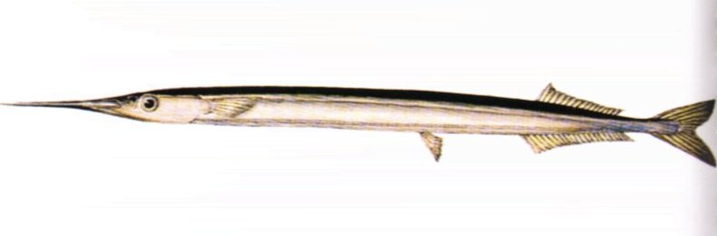
Garfish

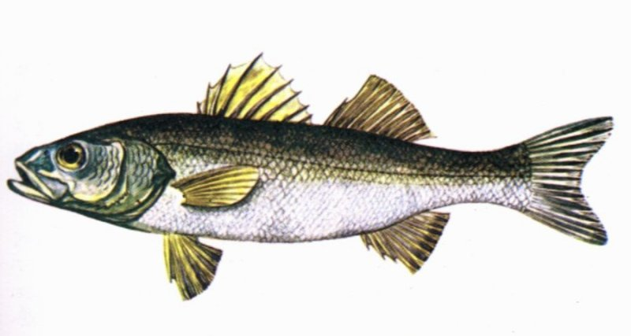Sea bass

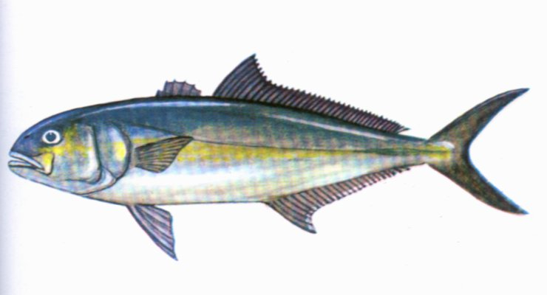Amberjack

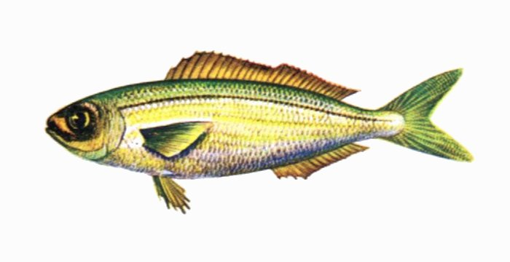Voppa/Bogue

