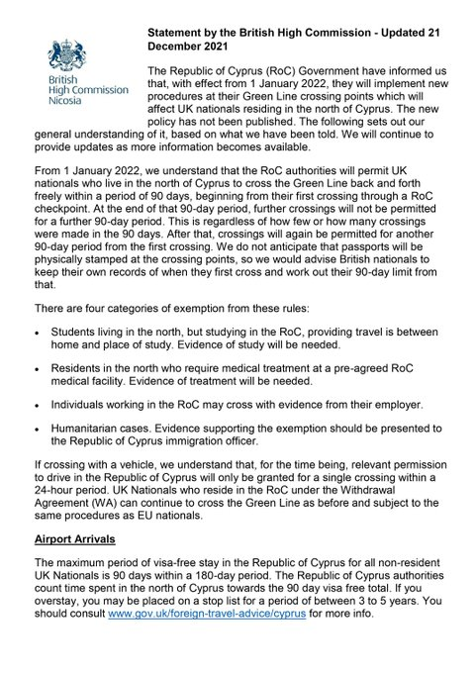
From https://twitter.com/UKinCyprus/status/1473290007540551691?s=20&t=4BxNn2JYXOzZE8bwAp0VNw accessed and printed 26/10/2022

